**Experiment No. 1**

### Title: Implementation of Linear regression in python (Single variable & Multivariable)

Regression is a statistical method used in finance, investing, and other disciplines that attempts to determine the strength and character of the relationship between one dependent variable (usually denoted by Y) and a series of other variables (known as independent variables).

### Linear Regression Single Variable:-

Below table represents current home prices in abc township based on square feet area

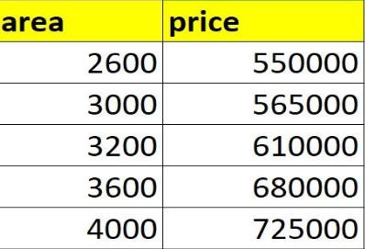

**Problem Statement**: Given above data build a machine learning model that can predict home prices based on square feet area

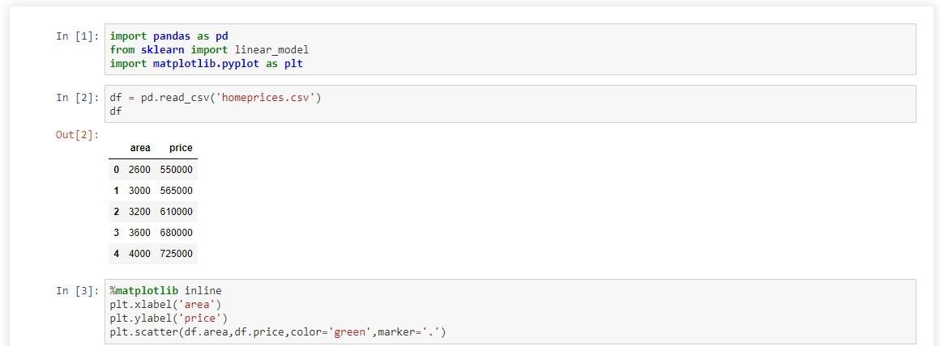

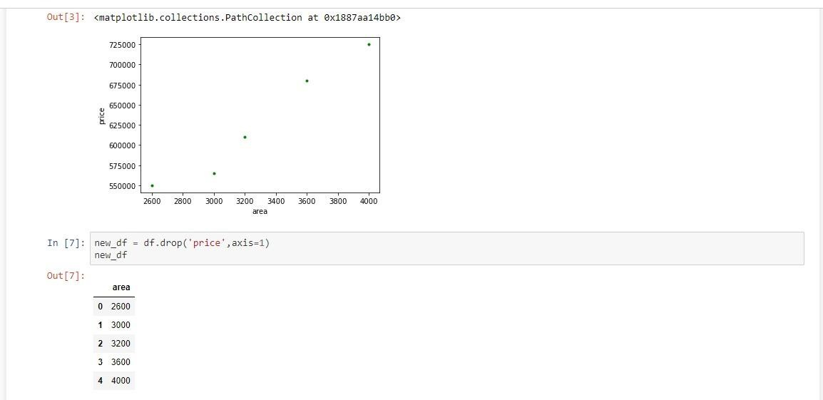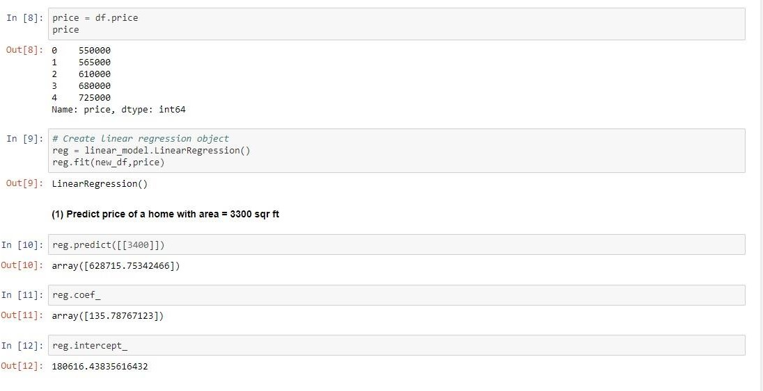

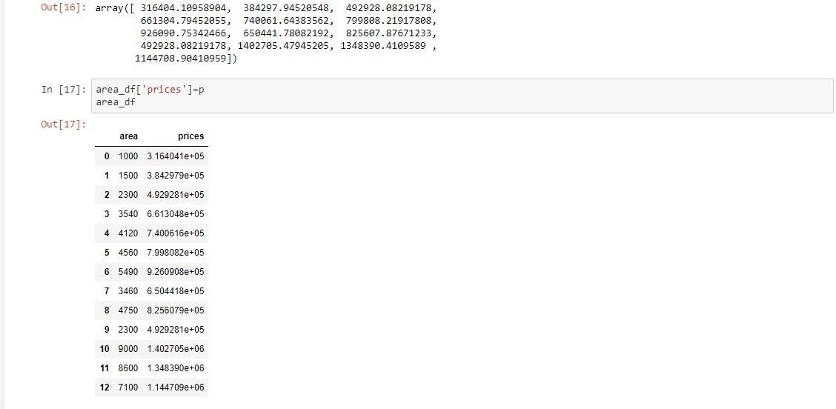

### Linear Regression MultiVariable:-

Now we have to predict the price of house based of many parameters like area, number of bedroom and age.

The objective is to predict the price of a house based on all the above mentioned parameters:-

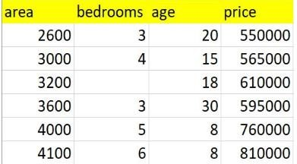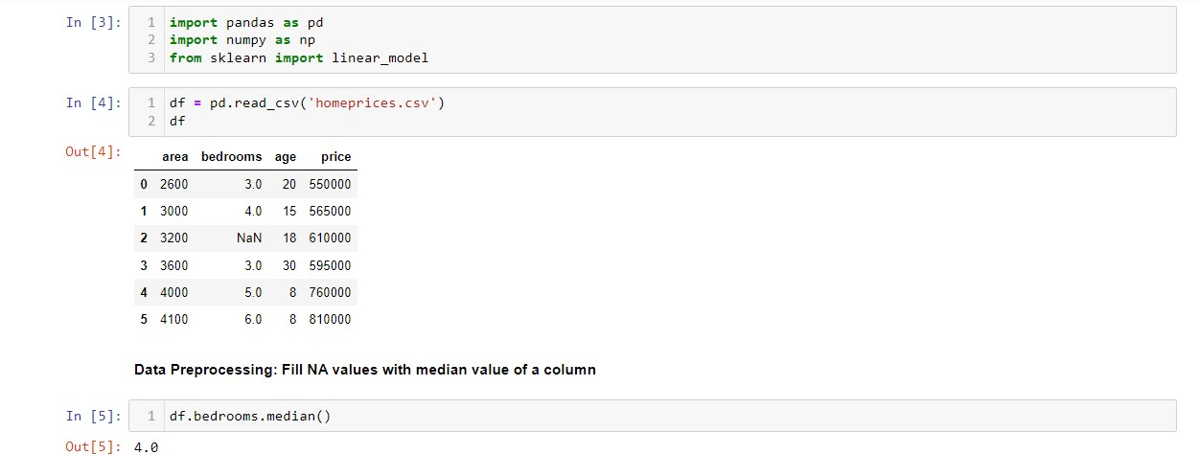

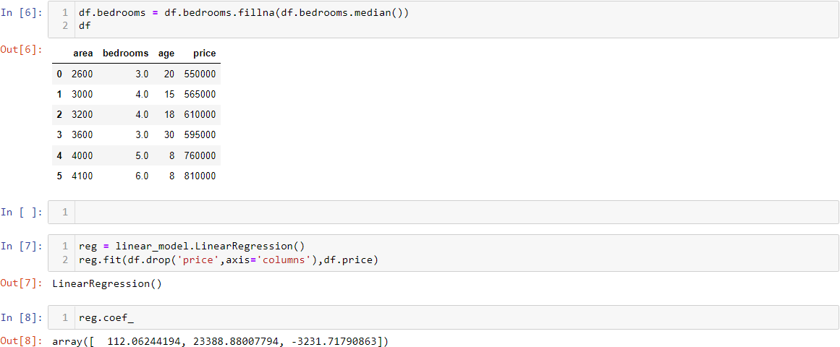

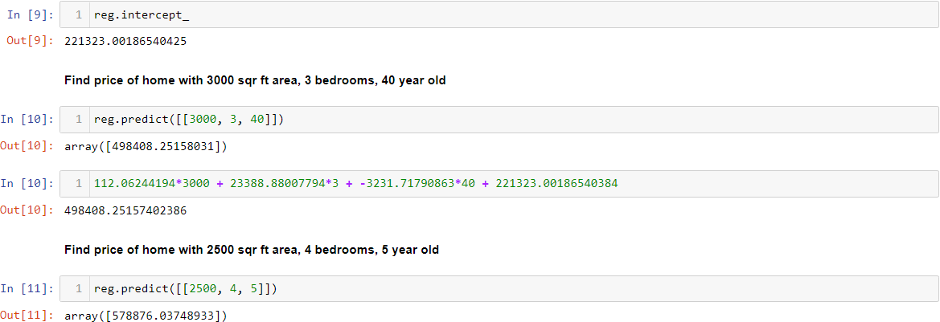

Simple linear regression is a regression model that figures out the relationship between one independent variable and one dependent variable using a straight line.

SOME APPLICATIONS WHERE WE CAN USE SIMPLE LINEAR REGRESSION

* 1. **Marks scored by students based on number of hours studied (ideally)-** Here marks scored in exams are independent and the number of hours studied is independent.
  2. **Predicting crop yields based on the amount of rainfall-** Yield is a dependent variable while the measure of precipitation is an independent variable.
  3. **Predicting the Salary of a person based on years of experience-** Therefore, Experience becomes the independent while Salary turns into the dependent variable.